Introducing Ron Crites “Variety Music Solo Artist
Ron is a native of Orlando, Florida now living in Nashville, Tennessee. He grew up with country music and has been playing guitar since he was twelve years old with his musical family consisting of nineteen children.
He has a wide variety of music on this play list of 250 plus songs from Traditional Country, Blues, Classic Rock and Roll, and Chickin’ Pickin’ Instrumentals. Ron performs as a Solo Artist with the aid of a “Digital SD3 Ketron Multimedia Music Station”. By using this system and kicking bass foot pedals to change all the chords in the song that he is playing, he sounds like a full band. He re-creates the sound of piano, brass, and a host of other musical instruments with his Casio MG510 Midi Guitar. Ron is not just a musician but an “Entertainer”. and a first-rate guitar picker who duplicates George Jones vocal style with uncanny accuracy”. His talent is known all over the world, his song, “Blue Roses” from his Plain Country 2 CD, reached number twenty-four on the INDIE CHARTS in Europe. At Emma, MO, Ron opened for George Jones, performing on stage in front of 7000 people for almost an hour, as a solo artist was a dream come true let alone getting a chance to see and hear his idol. Ron has performed on “Carnival Cruise Lines” since 2002. Playing seven different ships and 14 contracts which 11 of them were 6-months at a time. On one of the Grand Ole Opry Country Cruises Ron had the opportunity to meet Brad Paisley and Little Jimmy Dickens while they listened to him for over two hours. Yet another “Grand Ole Opry Cruise” again with Brad Paisley as he enjoyed the way Ron performed George Jones Songs, he was hired to perform at “Brad’s Fan Club Party” in Franklin , TN at “The Factory” Thanks For Listening!!
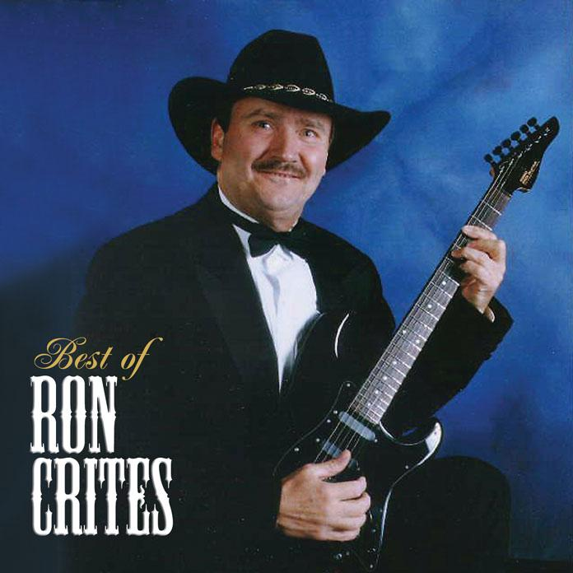
The Best Of Ron Crites CD Keep Um” Walking CD
$15.00 Each Or Get Both Of Them For $35.00
Ron Crites

Country Variety Music Solo Artist

Booking Information

615-294 4163

www.roncrites.com

Venmo- PayPal.me/roncrites  Cash App

www.GeorgeJonesTributeShow.com

Schedule and further info on website

 roncrites.com YouTube

